[CG Homework 3, due Thu 2016-09-22 9am](https://www.ecse.rpi.edu/Homepages/wrf/Teaching/graphics-f2016/posts/hw3/)

 W Randolph Franklin, RPI

[2016-09-07 14:50](https://www.ecse.rpi.edu/Homepages/wrf/Teaching/graphics-f2016/posts/hw3/)

1. *(10 pts)* Part of changing from one coordinate system to another is scaling and making things fit. E.g., suppose that you had a square with lower left corner (llc) (0,0) and upper right corner (urc) (1,1). You want to scale and center it to just fit into a rectangle with llc (0,0) and urc (2,3). The square stays a square but is probably larger or smaller. Then, these equations would do it:

x' = 2x

y' = 2y + 1/2

This question is to figure out how to make a rectangle from (0,0) to (2,3) fit into a square that is from (0,0) to (10,10).

*(10 pts)* Consider a pinhole camera as discussed in slide 12 of ppt presentation 1_5. Let d=2. To where does the point (1,3,-2) project? Use the equation on that slide. x/z/d should be parenthesized as x/(z/d).

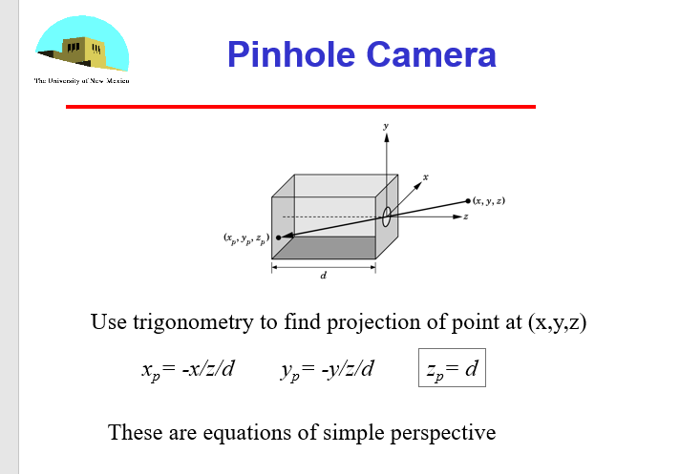

1. *(5)* If your image has only 64 different colors across the whole image, how many bits per pixel do you need for the color buffer?

http://www.tutorialspoint.com/dip/concept_of_bits_per_pixel.htm

6

1. *(25)* Extend your program from last week that displays the Starship Enterprise as follows:
   1. Add 3 sliders that will rotate it around the X-axis, Y-axis, and Z-axis respectively.
   2. Do the rotations the simplest (and least efficient) way. I.e., in your javascript program, have render rotate the matrix and resend it to the GPU.

*(Total: 50 points.)*